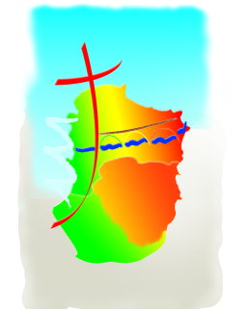
SAMEDI 02 | 17H | BELVEZE
DIMANCHE 03 | 9H30  10H30  11H | PAULIGNE  CHALABRE  LIMOUX ST MARTIN
SAMEDI 09 | 11H  17H | CHRISTINA  ST HILAIRE
DIMANCHE 10 | 9H30  10H30  11H | ST MARTIN DE VILLEREGLAN  CHALABRE  LIMOUX ST MARTIN
SAMEDI 16 | 16H | MISSEGRE
DIMANCHE 17 | 9H30  10H30  11H | GARDIE  CHALABRE  LIMOUX ST MARTIN
SAMEDI 23 | 11H  17H | CHRISTINA  BRUGAIROLLES
DIMANCHE 24 | 9H30  10H30  11H | AJAC  CHALABRE  LIMOUX ST MARTIN

